OC ASSIGNMENT -06

NAME- YASH GUPTA

ROLL NO.- S20200010195

**1. Define an array in 8086 and write an 8086-assembly language program to divide the element by 2 and store the reminder back into the array.**

* Defining an array containing 5 elements and storing remainder when each element is divided by 2

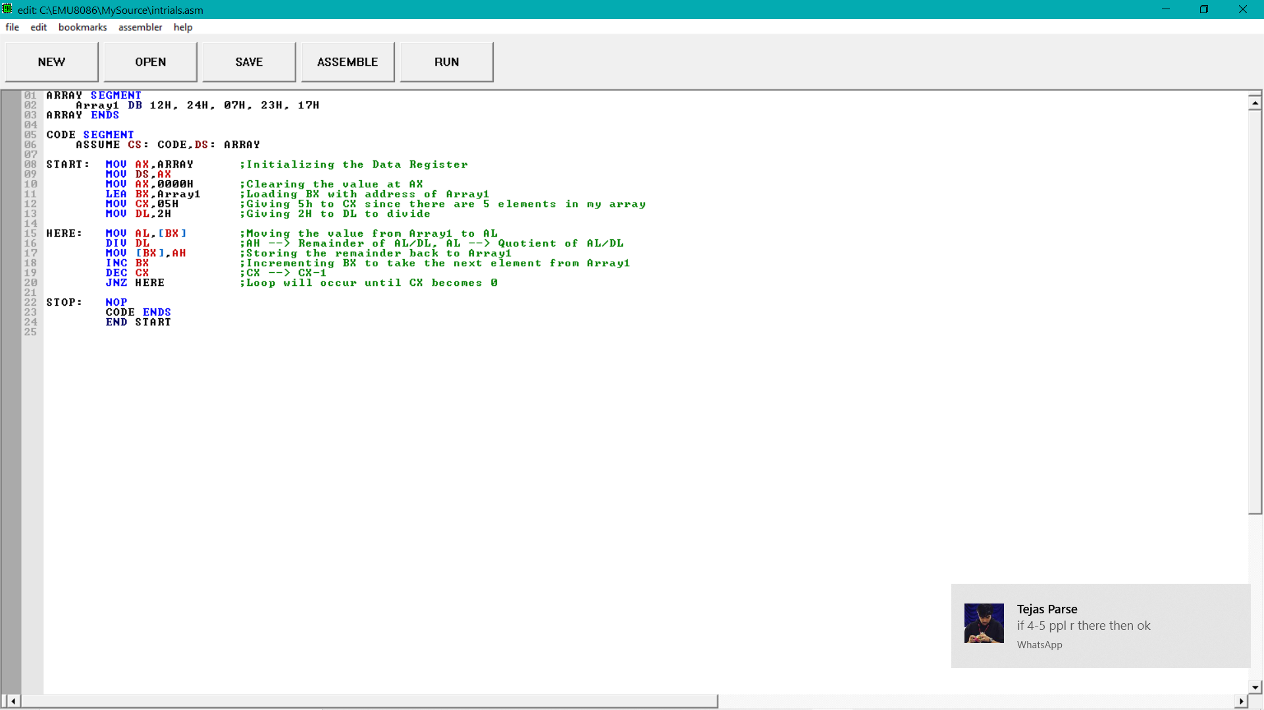

* Remainders are stored at location 0710:0000

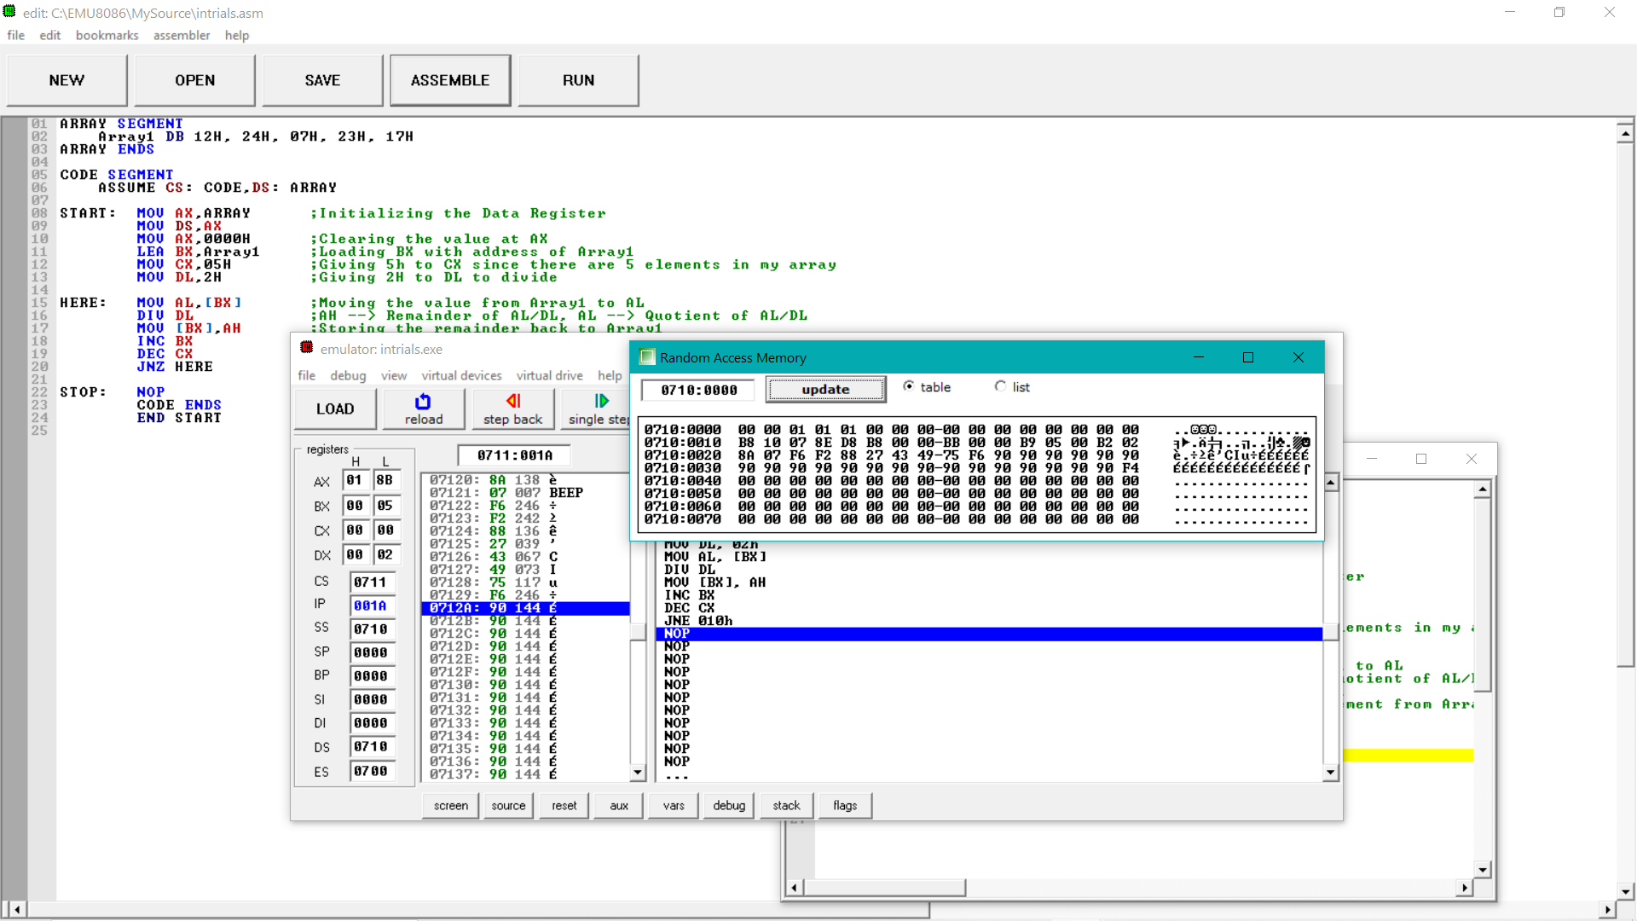

* Since I took 2 even numbers and 3 odd numbers the remainders are 00 00 01 01 01.

**2.Write an assemble language program to combine/store the following strings in continuous location in memory**

**String1: Ok**

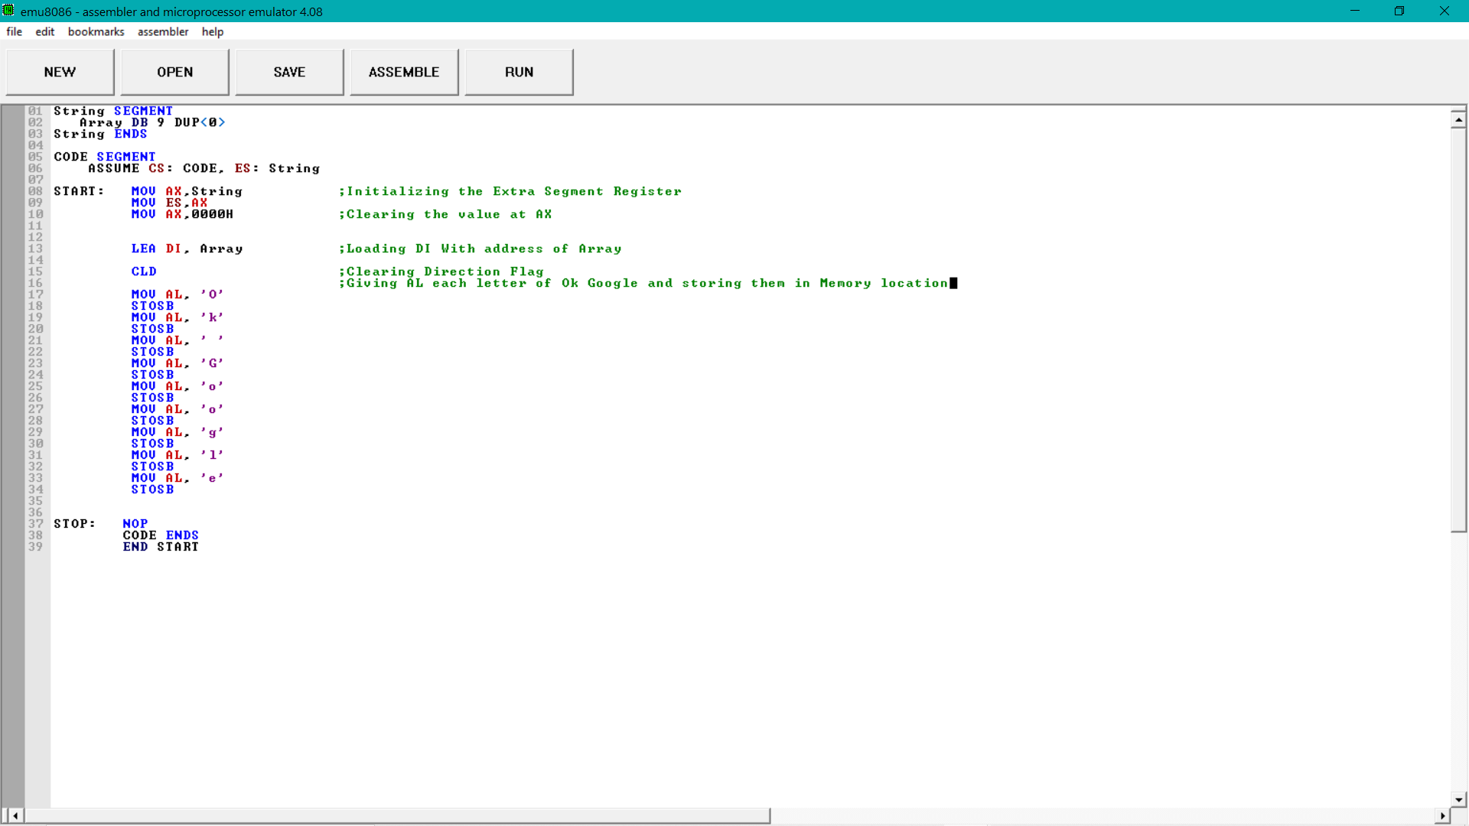 **String2: Google**

* **Memory Location 0710:0000 contains the string Ok Google**

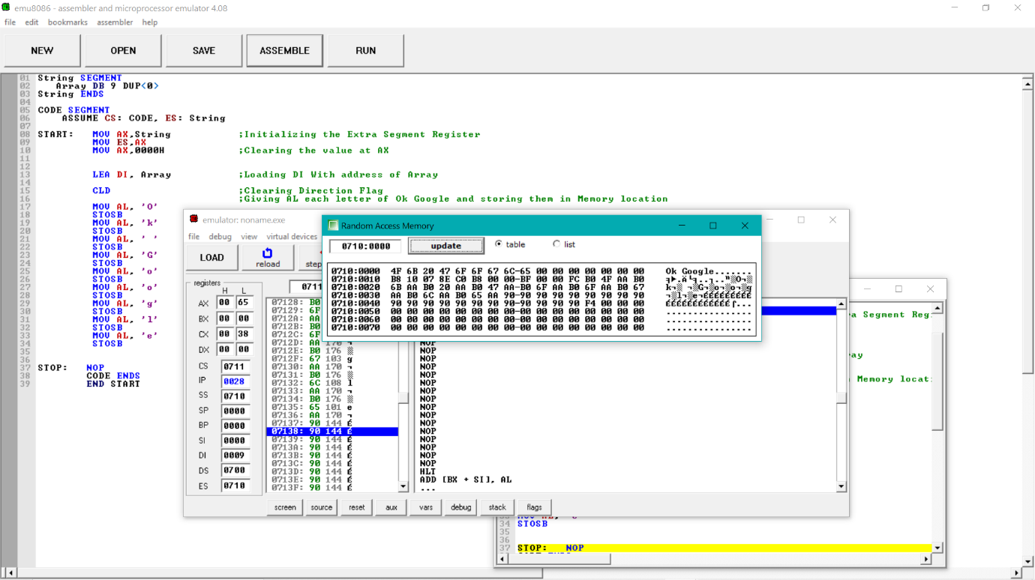

Conclusion

In this lab I have learnt how to use loops in 8086 and also how to make strings using it.